PGSuper™ Technical Note (TN001)

Configuring WSDOT Load Rating Options in an existing PGSuper™ Project File

# Background

Beginning May 1, 2010, load ratings are required for all new and ongoing WSDOT designs (See [Design Memo 03-2010](http://wwwi.wsdot.wa.gov/eesc/bridge/designmemos/03-2010.htm)). PGSuper Version 2.3 has LRFR load rating capabilities. The purpose of this document is to detail the steps necessary to configure a PGSuper Project Files created with PGSuper Version 2.2 or earlier to perform load rating calculations in accordance with the WSDOT Bridge Design Manual.

# New PGSuper Projects

The WSDOT PGSuper Project Templates have been pre-configured for the WSDOT load rating requirements. If you are creating a new project using PGSuper version 2.3 and the most recent libraries and templates, no additional steps are required. Follow the steps described in the next section to ensure you are using the most recent PGSuper Library and Templates.

# Updating PGSuper Library and Templates

Ensure that PGSuper is configured with the latest libraries and templates before configuring your project file for load rating.

1. Start PGSuper
2. Select Configure PGSuper from the File menu
3. Select the WSDOT library and templates package from the WSDOT server  
   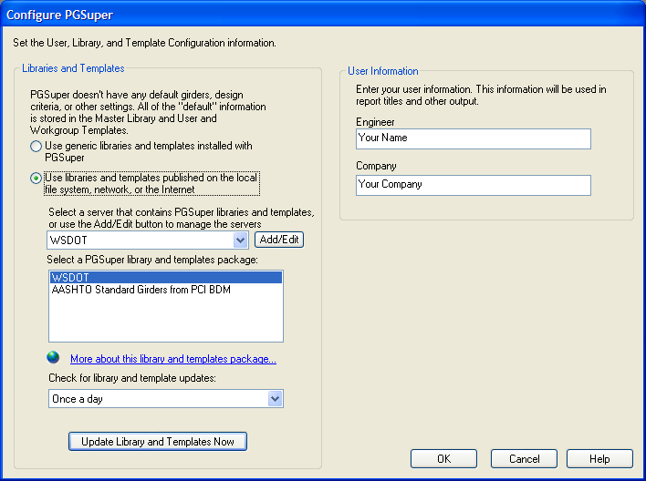
4. Press the Update Library and Templates Now button

# Configure Load Rating Options

To configure the load rating options:

1. Select Load Rating Options from the Project menu (or press the  button on the toolbar)
2. On the General Tab, select WSDOT as the Load Rating Criteria and check all three Rating Type boxes  
   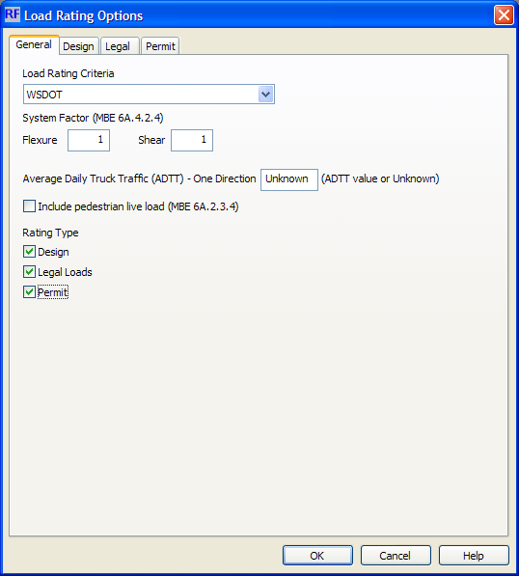
3. On the Permit tab, check the OL1 and OL2 vehicles in the Special/Limited Crossing Permit Rating Vehicles list and change the Permit Type to “Single Trip with other traffic”  
   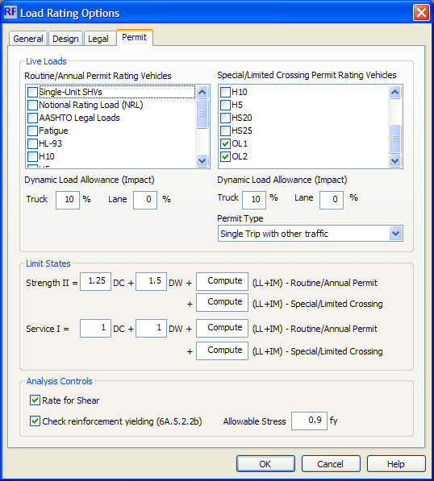
4. Save your PGSuper project file.

Your project file is ready to have PGSuper perform a load rating analysis.

# Load Rating Analysis

To perform the load rating analysis, simply create a Load Rating Report. The default configuration for this report contains minimum information that needs to be reported to the WSDOT Load Rating unit. Other chapters can be added to this report to get a more detailed record of the load rating analysis.

The WSDOT Load Rating Summary Report provides all of the information required for the Bridge Rating Summary Sheet, shown in Appendix 13.4-A1 of the BDM.

**PGSuper performs load rating calculations for the superstructure only. Load rating of the cross beam is required and must be done by other means.**